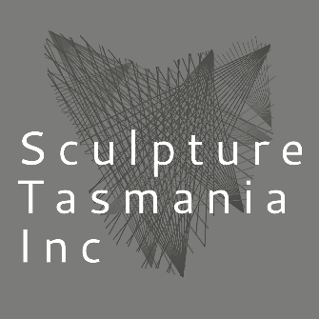

SCULPTURE TASMANIA INC ON-LINE SCULPTURE SHOP FOR MOST MEMBERS
Dear MoST Members,
Sculpture Tasmania wishes to introduce a MoST SCULPTURE SHOP on our web site for the sale of sculptures to a wide audience within Tasmania and beyond. We have practiced with a couple of members to see how it would work. As well, the aim of the SHOP is to increase the artist’s profile, and to build a network so artists can become part of the sculpture family. Members check out the concept at www.sculpturetasmania.com/store
We believe on-line shopping has become a normal retail avenue for pleasure and necessities and as we have the system in place for sales, we are going to give it a go! MoST MEMBERS please fill in and return the form below so your sculpture and name can be added to the site once over a period.
Click on the MoST SHOP images and the artists statement, work description and price POPS UP.
We ask participating artists to set a price for their work, Sculpture Tasmania will add 25% commission (or a commission suggested by you), postage, and handling costs to the basic price. Of course, we gratefully accept gifts of sculptures for the MoST SHOP as well.
This incentive will give Sculpture Tasmania a finance stream to sustain our not-for-profit association. Funds raised will go to maintaining and running the group plus we hope to build a revenue base which can be used to for further promotional avenues for MoST members.
If you are interested complete the forms below, we will be in touch and advise you of the date your work will be added to the MoST SCULPTURE SHOP site.

Look forward to hearing from you.
THE MoST SCULPTURE TEAM

APPLICATION FORM  MOST SCULPTURE SHOP |  | DETAILS
Artist’s Name

Artist’s Address

Artist’s Mobile Number

Artist’s email address

Title of work

Dimensions

Materials

Approx. Weight

Price Asked AUD

Artist Description of the Work (max 35 words)

Short Bio (max 100 words)

Artist’s Web Site Address
Image maximum 3MB on a white background to promote your work.

Yes No | Please promote my sculpture the following - Sculpture Tasmania’s Facebook, Instagram and web site.  (Mark yes or no)

This is a word document, please fill in the form and return to Craig Ashton marked attention MoST SHOP. The Application must include a clear image of the work for the web site shop. Craig’s email craigashtondesigns@bigpond.com
Artist’s Bank Details for sales payments –
Direct payment to your bank account can be made,

Bank Name:

The Account Name:

BSB:

A/C No:

